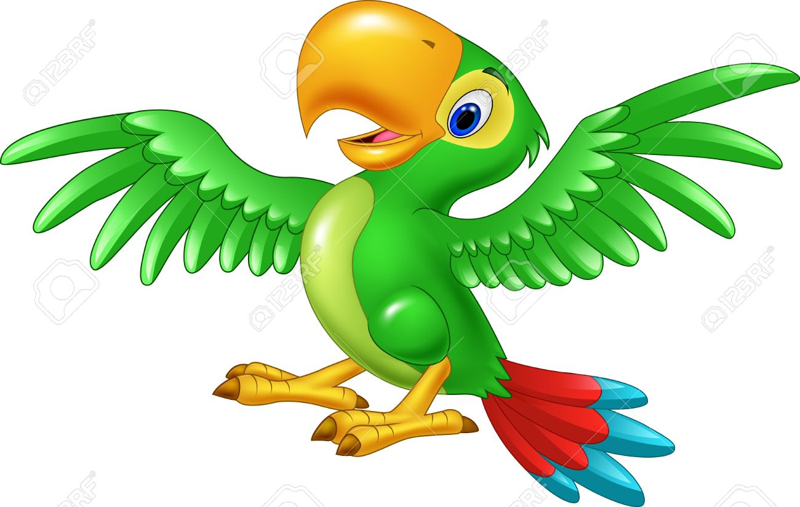

Hola buenas tardes

Mi animal favorito es el loro son aves de colores llamativos son muy inteligentes y en ocasiones aprenden a decir palabras, La cola de los loros suele ser bastante larga, Generalmente, se trata de animales sociables.

Hello good afternoon

My favorite animal is the parrot that is colorful birds of color and are very intelligent and in situations they learn to say words, the tail of the Lorries is usually quite long, generally, it is sociable animals.

